Project 0 Code
Marshall Roll
2026-02-03
## Rows: 372 Columns: 15
## ── Column specification ────────────────────────────────────────────────────────
## Delimiter: ","
## chr (1): Collection Date
## dbl (9): SubjectID, Collection Sample, Booklet: Sample interval Decimal Tim...
## time (5): Booket: Clock Time, MEMs: Clock Time, Sleep Diary reported wake ti...
##
## ℹ Use `spec()` to retrieve the full column specification for this data.
## ℹ Specify the column types or set `show_col_types = FALSE` to quiet this message.

Cleaning

Table 1
## The number rows in the tables to be merged do not match, which may result in
## rows appearing out of order.
## ℹ See `tbl_merge()` (`?gtsummary::tbl_merge()`) help file for details. Use
## `quiet=TRUE` to silence message.
 | By Sample |  |  |  | Total
Characteristic | 1 N = 93¹ | 2 N = 93¹ | 3 N = 93¹ | 4 N = 93¹ | N = 372²
Wake to Booklet Time (Minutes) | 0.90 (3.71) | 34.40 (9.55) | 322.85 (84.87) | 641.50 (84.19)
(Missing) | 5 | 6 | 11 | 13
Wake to Cap Time (Minutes) | 5.12 (9.20) | 50.11 (34.97) | 323.41 (79.63) | 658.86 (99.07)
(Missing) | 16 | 23 | 12 | 10
Cortisol (nmol/L) | 7.38 (6.05) | 9.00 (4.94) | 3.21 (2.29) | 3.20 (4.98)
(Missing) | 0 | 1 | 2 | 3
DHEA (nmol/L) | 1.78 (1.27) | 1.11 (0.92) | 0.51 (0.46) | 0.50 (0.65)
(Missing) | 0 | 1 | 2 | 2
Good Adherence (7.5 min) | 0 (0%) | 68 (73%) | 0 (0%) | 37 (40%)
(Missing) | 88 | 0 | 82 | 0
Adequate Adherence (15 min) | 0 (0%) | 78 (84%) | 0 (0%) | 45 (48%)
(Missing) | 88 | 0 | 82 | 0
Complete Booklet |  |  |  |  | 337 (91%)
Complete Cap |  |  |  |  | 311 (84%)
Complete |  |  |  |  | 285 (77%)
¹Mean (SD); n (%)
²n (%)

Missingness Evaluation
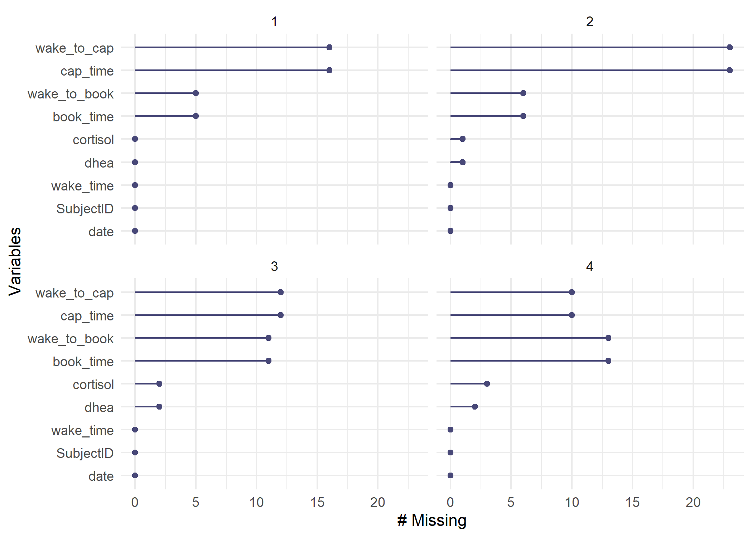

RQ1 - Cap & Book Time Agreement
##
## Repeated measures correlation
##
## r
## 0.9934941
##
## degrees of freedom
## 253
##
## p-value
## 9.710101e-241
##
## 95% confidence interval
## 0.9916795 0.994914
## Linear mixed model fit by REML. t-tests use Satterthwaite's method [
## lmerModLmerTest]
## Formula: wake_to_cap ~ wake_to_book + (1 | SubjectID)
## Data: cort_final
##
## REML criterion at convergence: 2786.5
##
## Scaled residuals:
## Min 1Q Median 3Q Max
## -4.3591 -0.2959 -0.1806 -0.0200 5.9957
##
## Random effects:
## Groups Name Variance Std.Dev.
## SubjectID (Intercept) 44.84 6.696
## Residual 985.02 31.385
## Number of obs: 285, groups: SubjectID, 31
##
## Fixed effects:
## Estimate Std. Error df t value Pr(>|t|)
## (Intercept) 10.17062 2.87772 63.61855 3.534 0.000768 ***
## wake_to_book 0.99097 0.00703 262.70808 140.967 < 2e-16 ***
## ---
## Signif. codes: 0 '***' 0.001 '**' 0.01 '*' 0.05 '.' 0.1 ' ' 1
##
## Correlation of Fixed Effects:
## (Intr)
## wake_to_bok -0.628
## `geom_smooth()` using formula = 'y ~ x'
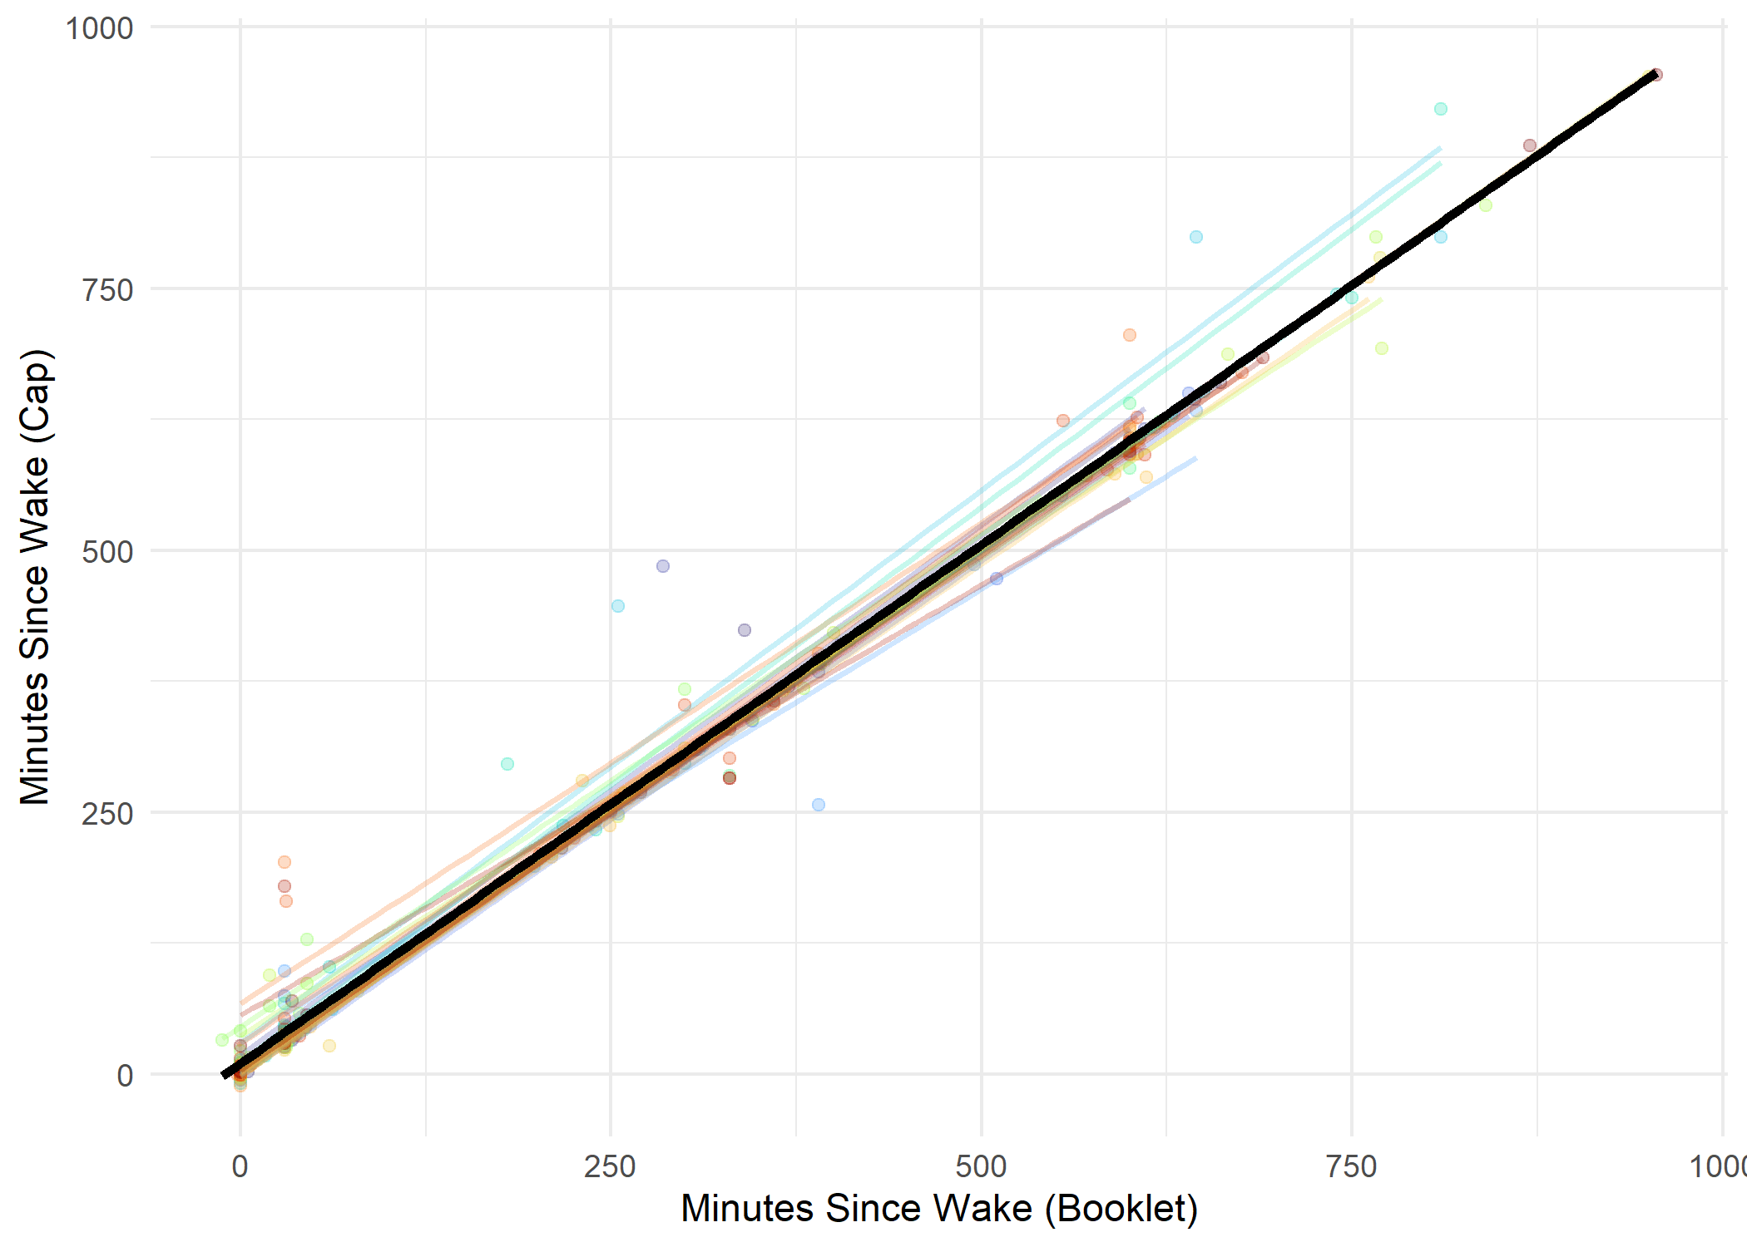
To assess the agreement between cap and booklet time, a random intercepts model was fit with cap time since wake as the outcome and booklet time as the outcome. There is a slight systematic difference between the two recording methods, with cap readings occurring an average of about 10 minutes later than booklet recordings and slight subject-specific variability (random intercept SD = 6 minutes). Within-subject correlation for complete cases is very high (repeated measures correlation, r = 0.99). Between 20-30% of observations were incomplete at each of the four time points, with most time points having higher levels of missingness in the cap compared to the book.

RQ2: Adherence to Timing Schedule
## # A tibble: 1 × 2
## prop_7.5 prop_15
## <dbl> <dbl>
## 1 72 80.6
## # A tibble: 1 × 2
## prop_7.5 prop_15
## <dbl> <dbl>
## 1 37.6 47.3
## Picking joint bandwidth of 11.7
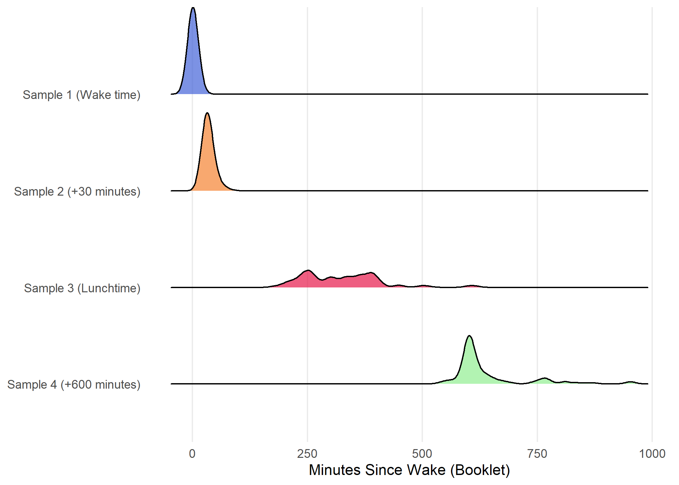

RQ3: Cortisol & DHEA analysis
## Linear mixed model fit by REML. t-tests use Satterthwaite's method [
## lmerModLmerTest]
## Formula: log(cortisol) ~ wake_to_book + wake_30 + (1 | SubjectID)
## Data: cort_final
##
## REML criterion at convergence: 826
##
## Scaled residuals:
## Min 1Q Median 3Q Max
## -3.3204 -0.5099 0.0511 0.5706 3.7613
##
## Random effects:
## Groups Name Variance Std.Dev.
## SubjectID (Intercept) 0.1046 0.3234
## Residual 0.5787 0.7607
## Number of obs: 335, groups: SubjectID, 31
##
## Fixed effects:
## Estimate Std. Error df t value Pr(>|t|)
## (Intercept) 1.697041 0.101712 102.889100 16.685 <2e-16 ***
## wake_to_book 0.004364 0.003728 302.157726 1.171 0.2426
## wake_30 -0.006462 0.003826 302.179450 -1.689 0.0923 .
## ---
## Signif. codes: 0 '***' 0.001 '**' 0.01 '*' 0.05 '.' 0.1 ' ' 1
##
## Correlation of Fixed Effects:
## (Intr) wk_t_b
## wake_to_bok -0.613
## wake_30 0.598 -0.999
## Linear mixed model fit by REML. t-tests use Satterthwaite's method [
## lmerModLmerTest]
## Formula: log(dhea) ~ wake_to_book + wake_30 + (1 | SubjectID)
## Data: cort_final
##
## REML criterion at convergence: 745.6
##
## Scaled residuals:
## Min 1Q Median 3Q Max
## -4.5749 -0.5351 0.0157 0.6027 2.5260
##
## Random effects:
## Groups Name Variance Std.Dev.
## SubjectID (Intercept) 0.2972 0.5452
## Residual 0.4094 0.6398
## Number of obs: 336, groups: SubjectID, 31
##
## Fixed effects:
## Estimate Std. Error df t value Pr(>|t|)
## (Intercept) 0.269309 0.120767 52.994580 2.230 0.03 *
## wake_to_book -0.019091 0.003137 303.582802 -6.087 3.48e-09 ***
## wake_30 0.017641 0.003219 303.596139 5.480 8.95e-08 ***
## ---
## Signif. codes: 0 '***' 0.001 '**' 0.01 '*' 0.05 '.' 0.1 ' ' 1
##
## Correlation of Fixed Effects:
## (Intr) wk_t_b
## wake_to_bok -0.434
## wake_30 0.423 -0.999
Effect | Percent Change/30 min | 95% CI | p-value
Before 30 min | 13.99 | (-10.99, 45.98) | 0.395
After 30 min | -6.10 | (-7.27, -4.92) | <0.001
Effect | Percent Change/30 min | 95% CI | p-value
Before 30 min | -43.60 | (-54.2, -30.55) | <0.001
After 30 min | -4.26 | (-5.26, -3.24) | <0.001
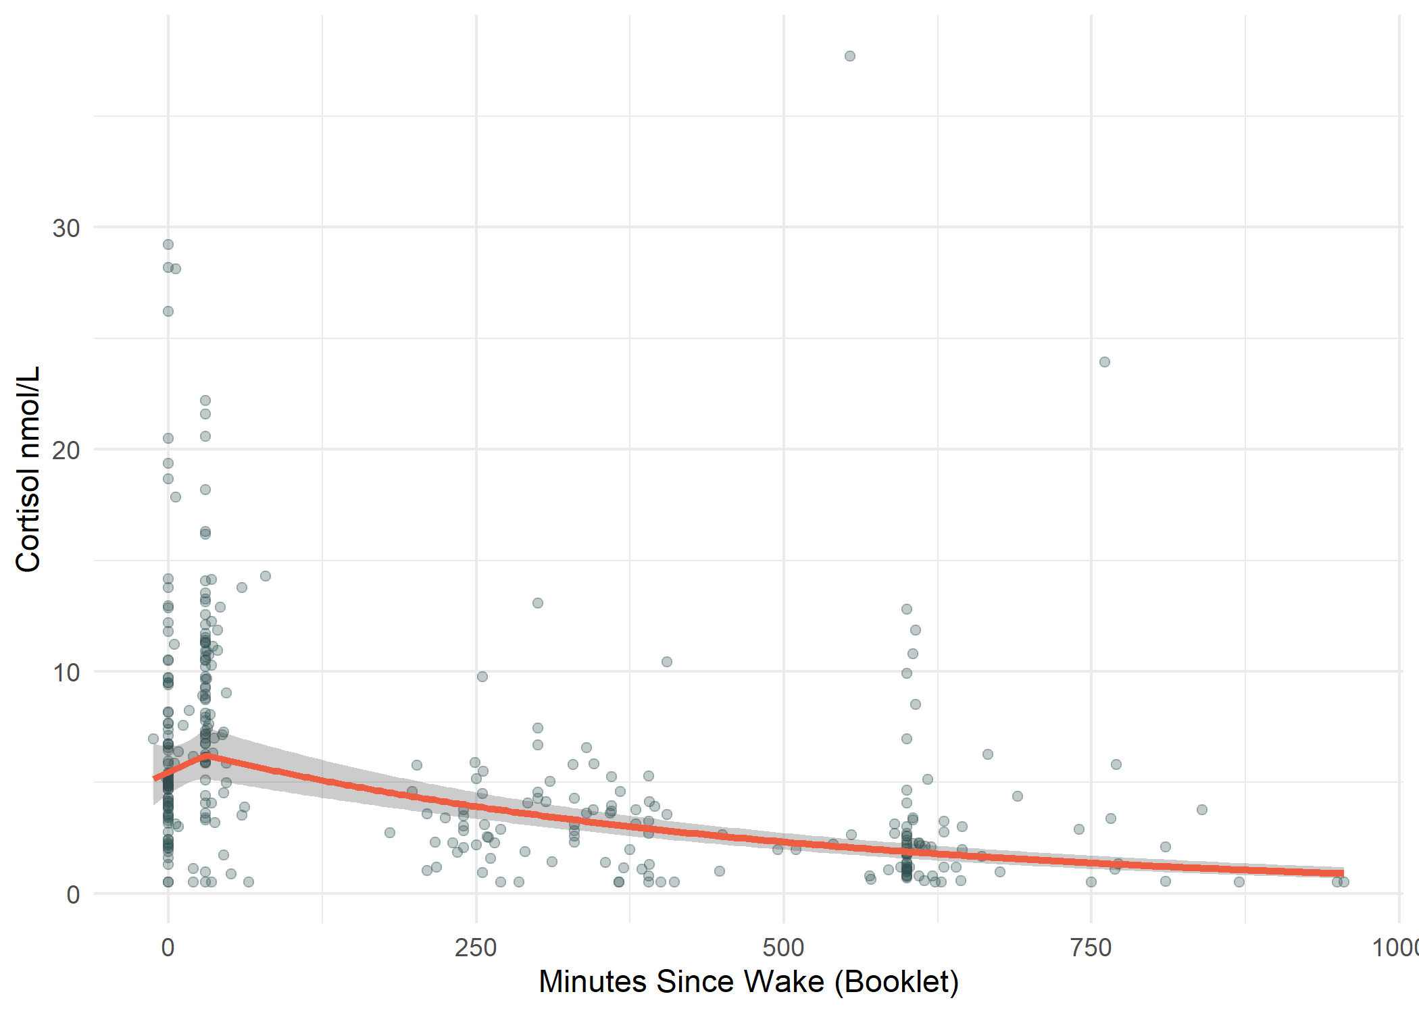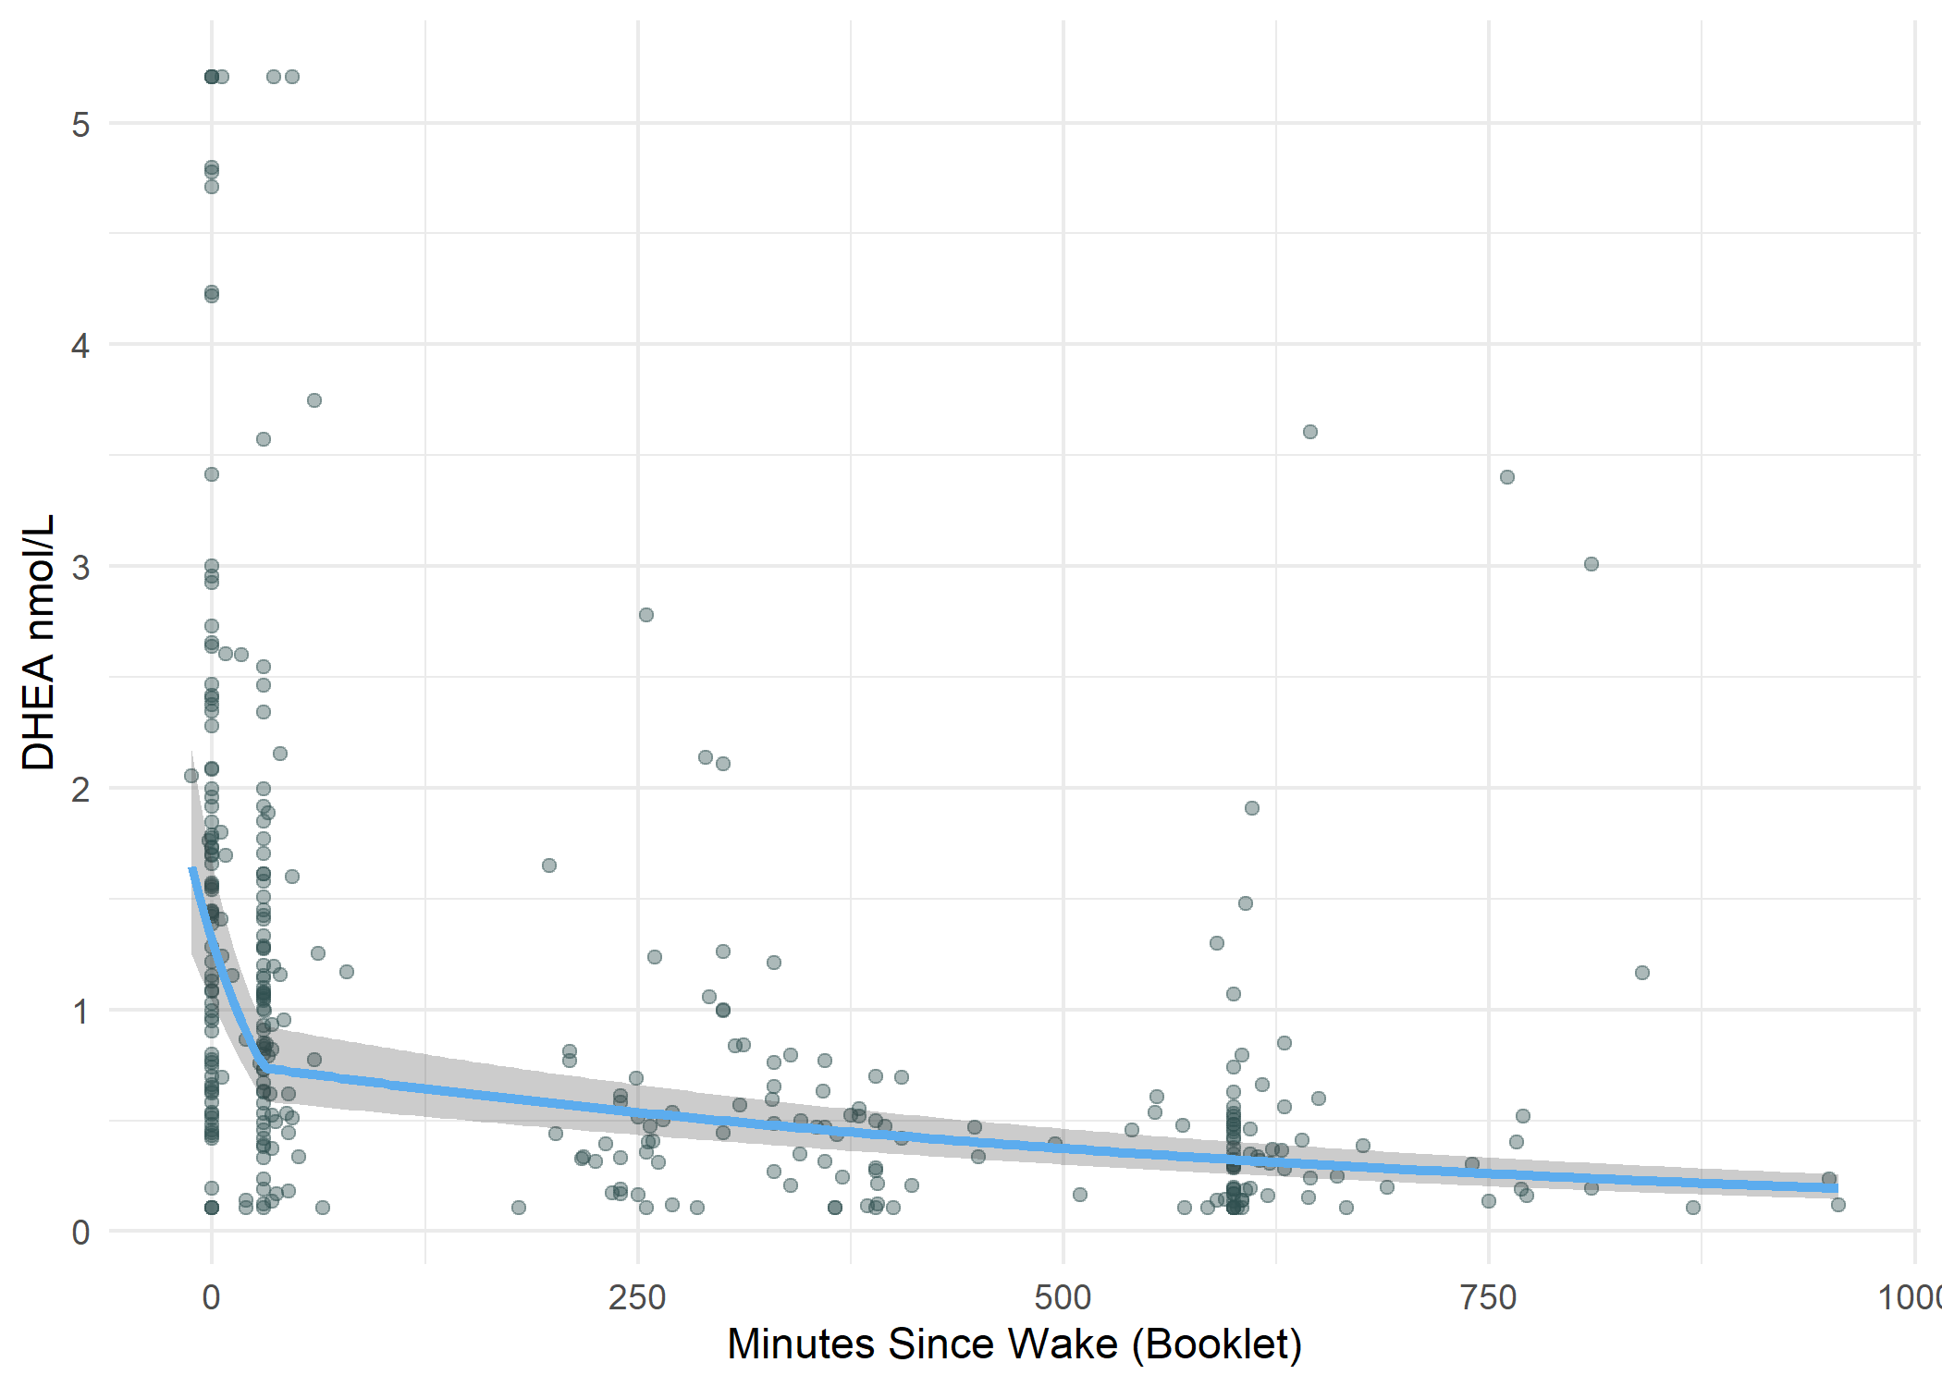
Outcome: time since reported wakeup time Agreement: On average, are cap and booklet time similar? 1) Test of association, rate of bias (sleep diary wake time - book time/Cap time; calculate manually) 2) Table/figs, adherence: good = 7.5 mins, adequate = 15 mins 3) Wakeup - 30, rate of decline post-30 mins, use moles
26+ cortisol possible but unlikely exclude cortisol over 80
Upper Limit DHEA: 5.205 nmol/L
- Mixed effects model with RI for subject or Repeated Measures correlation?
– scatterplot for booklet time since wake vs cap time
- Tables/figures
- 2 random effects models

